Adverb Phrase (AdvP) as Head

🟩 What is Adverb Phrase (AdvP) as Head
# Source: AI Source: Provided by: [Data Path: Persons Table -> ID Column: 1, Name_En Column: Motasem Essam] -> From: [Chatgpt (GPT‑5 Mini)] on [8/7/2025]
In an Adverb Phrase (AdvP), the head is an adverb, which can be modified by other words (usually intensifiers or degree modifiers). The head determines the role of the whole phrase, typically modifying a verb, adjective, another adverb, or even a whole clause.

🔹 Common Types of Adverb Phrase Heads
# Source: AI Source: Provided by: [Data Path: Persons Table -> ID Column: 1, Name_En Column: Motasem Essam] -> From: [Chatgpt (GPT‑5 Mini)] on [8/7/2025]
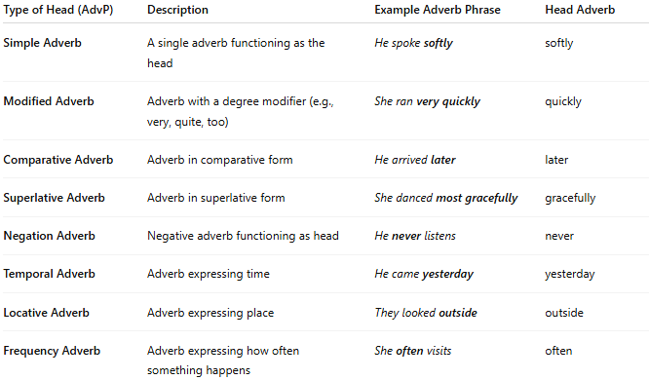
Type of Head (AdvP) | Description | Example Adverb Phrase | Head Adverb
Simple Adverb | A single adverb functioning as the head | He spoke softly | softly
Modified Adverb | Adverb with a degree modifier (e.g., very, quite, too) | She ran very quickly | quickly
Comparative Adverb | Adverb in comparative form | He arrived later | later
Superlative Adverb | Adverb in superlative form | She danced most gracefully | gracefully
Negation Adverb | Negative adverb functioning as head | He never listens | never
Temporal Adverb | Adverb expressing time | He came yesterday | yesterday
Locative Adverb | Adverb expressing place | They looked outside | outside
Frequency Adverb | Adverb expressing how often something happens | She often visits | often

✅ Notes:
# Source: AI Source: Provided by: [Data Path: Persons Table -> ID Column: 1, Name_En Column: Motasem Essam] -> From: [Chatgpt (GPT‑5 Mini)] on [8/7/2025]
- The head of an adverb phrase is always the main adverb.
- Modifiers (e.g., very, almost, quite) intensify or alter the meaning but are not heads.
- Adverb phrases can occur at the beginning, middle, or end of a sentence, depending on what they modify.

